Standard Operating Procedure (SOP)

SOP Title | Nuffield Health patient induction (WP4)
Version Number | 1.0
Approval Date
Effective Date

 | Name | Title | Signature | Date
Author | Sophie Reale | Research Fellow | 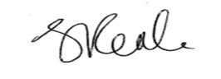 | 08/10/2021
Reviewer | Liam Bourke | Professor of cancer research |  | 19.11.21
Authoriser | Liam Bourke | Professor of cancer research |  | 19.11.21

Version log

Version | Date Approved | Reason for Change | Author
1.0

1.0 Purpose

This procedure is aimed at establishing safe and reliable practises when STAMINA Lifestyle Intervention (SLI) participants attend Nuffield Health for their induction session. It also covers recording and transferring data to the SHU research team.

2.0 Scope

This SOP is relevant to Nuffield Health staff that have been trained in the STAMINA intervention.

3.0 Background

- Up to 24 Nuffield Health sites will be recruited and paired with an NHS site for the delivery of work package 4 and 5 of the STAMINA programme.

- SLI participants will have provided informed consent, undergone a health screening check and a baseline assessment with the SHU research team in conjunction with the NHS.

- SLI participants will be referred to Nuffield Health for 12 months of supervised exercise following an induction session.

4.0 Responsibilities

- The SHU research team have responsibility of ensuring data is stored and communicated to NHS teams and with Nuffield Health sites accurately and securely.
- The Nuffield Health team have responsibility of recording and storing all data from the STAMINA study accurately and securely.
- The Nuffield Health team have responsibility for following the research protocol and making sure that all transfer of research data to the SHU research team is done from @nuffieldhealth.com to @nhs.net.
- The NHS site PI has overall responsibility for patient safety.

5.0 Procedure

Patient induction session
As part of the SLI participant induction session, the clinical exercise specialist will be expected to perform the following actions:

- Provide a brief tour of the gym and facilities
- Explore patient attitude and expectations (page 12 - 16 of the STAMINA diary)
- Provide support on how to use the RPE scale.
- Conduct the sub-maximal exercise test.
- Tailor and discuss details of the exercise prescription.
- Explain membership details and access.
- Discuss and schedule time for weekly supervised sessions.

Step 1: Provide a brief tour of the gym and facilities

Provide the SLI participant with a tour of the gym. Explain the difference between things like aerobic and resistance training equipment and how any electronic displays on machines work. For those who have never been in a gym before, it would be helpful to take them in to the changing rooms and show them how lockers work, how to access showers and the pool (where available).

If the SLI participant is amenable (and is wearing suitable clothing) allow them to use a couple of pieces of aerobic and resistance equipment (e.g., 5 minutes on an aerobic ergometer and 1 or 2 sets of resistance exercise at a conservative intensity). Demonstrate safe use first of each piece of equipment and watch for proper technique whilst the patient is using the equipment.

Step 2: Explore patient attitude and expectations

Use page 12 - 16 of the STAMINA diary to explore patient attitude towards exercise and participating in the STAMINA programme.

Discuss the benefits of exercise
Elicit what their expectations are using open-ended and follow-up questions so these can be aligned to reality. Inform them of the anticipated outcomes of supervised exercise for men on ADT, e.g., improve quality of life, feel less fatigue, reduce aches and pains.

Explore worries and concerns
The patient may be feeling nervous about starting exercise, meeting new people or being in a gym environment - this is very common. Use open-ended questions and follow up questions to find out how the patient is feeling. Provide reassurance using evidence and challenge assumptions where appropriate.

Explore exercise importance and confidence
Use the 0-10 rulers to find out how important exercise is to the SLI participant right now. Provide them with the pen to provide autonomy. Remember to use follow up questions to explore their score e.g., I notice you have scored yourself as a 4, what would it take to make it a 6? Why is it not a 2?

Repeat this activity to explore how confident the SLI participant is to exercise.

Explore pros and cons
Use open ended questions to explore what the SLI participant thinks are the benefits/ pros/ advantages of exercise for them. Repeat this activity for the disadvantages/ cons of exercising. It is important to explore both.

Listen to the SLI participant instead of telling them the advantages/ disadvantages that are relevant to you - remember everyone is different. Challenge beliefs where appropriate.

Problem solving
Use open-ended questions to find out if the SLI participant has any barriers to participating in the STAMINA programme. If these are identified, guide the SLI participant to come up with potential solutions. Ask the SLI participant how confident they are that the solutions will work and how likely they are to do them. Use this method to identify one suitable solution.

Remember this should be participant led - do not tell them what to do.

Step 3: Provide support on how to use the RPE scale.

Explain to men that rate of perceived exertion (RPE) will be monitored throughout supervised exercise sessions as a method to monitor exercise intensity. Emphasise to men that the RPE scale is not a typical 0 – 10 scale. Instead, men will be asked to provide ratings using the words on the scale as cues. The target is to exercise between a 3 and 5 (moderate to hard) (see appendix 1).

Explain to men that during aerobic exercise you will ask them how hard they think they are working, including how hard their breathing is and general sense of effort. Explain that during resistance exercise you will be asking them to report RPE in relation to the amount of effort required by the muscles they have been using for that exercise (as opposed to the whole body), at the end of each set.

Step 4: Conduct the sub-maximal exercise test

To gain an indication of what level of exercise tolerance each patient has initially, each SLI participant will need to undertake a sub-maximal exercise test. This can be done on either a treadmill¹ or exercise bike (only use the bike if it is unsafe to use a treadmill). The test is a basic graded exercise test. Results of the submaximal exercise test should be recorded in the participants SLI logbook.

Steps in performing the submaximal test:
1. Ascertain whether it is safe to conduct the test on a treadmill with each patient. If it is, use the treadmill for the test. If there are potential safety concerns e.g. issues around balance/stability/anxiety using the treadmill, use the bike test instead.

2. Familiarise yourself with the increments of intensity at each time interval for the test so you are prepared to smoothly make indicated increases as the test goes on. These are in appendix 2 of this document.

3. Explain how the test works, what you will be recording during the test and how the RPE scale works that will be used during the test.

4. Inform the SLI participant that the test continues to voluntary exhaustion or when the patient reaches an 8 on the RPE scale (whatever happens first). Emphasise that this is not a maximal test. Patients should aim for at least a 5 or 'hard' on the RPE scale,^{2,3} but can terminate before that if need be.

5. Demonstrate safe use of the treadmill or bike.

6. Set the initial level of intensity for the test - see appendix 2.

7.Change the speed/ gradient in line with the protocol.

8. Record RPE at each minute in the SLI logbook. At the end of the test, record the patients final RPE, total time and reason for test termination (please refer to the key at back of the SLI logbook). If the test was not performed please provide a reason. – see appendix 3.

Step 5: Tailor the exercise prescription

- Review the SLI participant referral notes and copy these across into the SLI Logbook. These documents detail the patients existing co-morbidities, medications, functional limitations, and exercises to avoid. Further detail about data collection can be found in the data collection SOP (4).

- Confirm the information with the patient and add any additional notes that are required. If the patient provides any changes to their health that you are unsure of, please contact the STAMINA research team immediately.

- Refer to the ‘tailoring for clinical populations document.’ This document contains guidelines on how to adapt prescriptions for chronic conditions, including:
- Managed asthma or COPD
- Stable angina or any other managed heart condition
- Asymptomatic fasted glucose over 8.0mml or over 17.0 mml for diabetics
- BMI over 35
- High total cholesterol

- Determine whether a run-in period is required. Some SLI participants will be referred to the STAMINA programme without any exercise experience and in a de-conditioned state. For these individuals, it might be appropriate to use a 'run-in' period before applying the full STAMINA intervention exercise prescription. This involves specifying a reduced overall training volume initially, to get the SLI participant used to exercising regularly before the full STAMINA prescription is met. There is a minimum attendance required of one supervised session per week for a run-in period. An example of how to set a run-in period can be found in appendix 4.

- After taking account of any existing health conditions and any necessary run-in period, you need to discuss and agree an initial exercise prescription with the patient. This needs to be within the scope of the STAMINA intervention, i.e.

- Aerobic
30-45 min of 60-85% HRmax or 40-60% HRR or 3-5 i.e., moderate to hard on the CR-10 RPE scale.

- Resistance
Up to 4 sets, 8-12 reps of major muscle groups, approx. 60% of 1RM, or 3-5 i.e., on the CR-10 RPE scale.

After your discussion you will need to agree specifics for each patient including specific aerobic ergometers to use in the gym, which major muscle groups you will be targeting for improving strength, initial intensity ranges (use the treadmill test result to guide you), initial duration of each session and plans for progression (we recommend reviewing the initial prescription after a maximum of six weeks).

- You must document the details of any run-in period and notify the STAMINA research team as soon as possible providing as much detail as you can. Further information on this process can be found in the data collection SOP (4). An example can also be seen in appendix 5.

Note: any unexplained chest pain during exercise needs to be referred to STAMINA team for discussion with PI.

Step 6: Explain membership details and access
SLI participants will not necessarily have been in a gym or health and fitness facility before. Some may be coming to the study from a background of a sedentary/chronically inactive lifestyle. Explain what's available at the gym, opening times, parking, what the patients can access, how they can access various services/facilities, suitable clothing, and basic gym etiquette.

The clinical exercise specialist should refer the patient to the fitness manager to issue the membership card and explain that the patient has access to the facilities for a total of 12 months.

Step 7: Discuss and arrange times for weekly supervised sessions
Inform SLI participants how the STAMINA programme is running at your site, i.e., twice weekly supervision in week 1 – 12, starting one-to-one before transitioning to small groups followed by tapered supervision in week 13 – 52 (once a month maximum, one every three months minimum).

Agree what time, which day and with whom the patients first supervised exercise session will be with. Remind them how long the first session will last, what to wear, where to meet their allocated CES and how to book future sessions. Information about booking sessions can be found in the scheduling and booking sessions SOP (5).

SLI logbooks
All participants will have an SLI logbook which will contain all their study data. SLI logbooks need to be stored in a secured room with controlled access.

6.0 References, Related SOPs, Web links

1. Kaminsky LA, Whaley MH. Evaluation of a new standardized ramp protocol: the BSU/Bruce Ramp protocol. J Cardiopulm Rehabil 1998;18:438-44.
2. Foster C, Florhaug JA, Franklin J, et al. A new approach to monitoring exercise training. Journal of strength and conditioning research / National Strength & Conditioning Association 2001;15:109-15.
3. Haddad M, Stylianides G, Djaoui L, Dellal A, Chamari K. Session-RPE Method for Training Load Monitoring: Validity, Ecological Usefulness, and Influencing Factors. Frontiers in neuroscience 2017;11:612.
4. Nuffield Health Data collection SOP
5. Nuffield Health Scheduling and booking in supervised exercise SOP

Appendix 1.

RPE scale

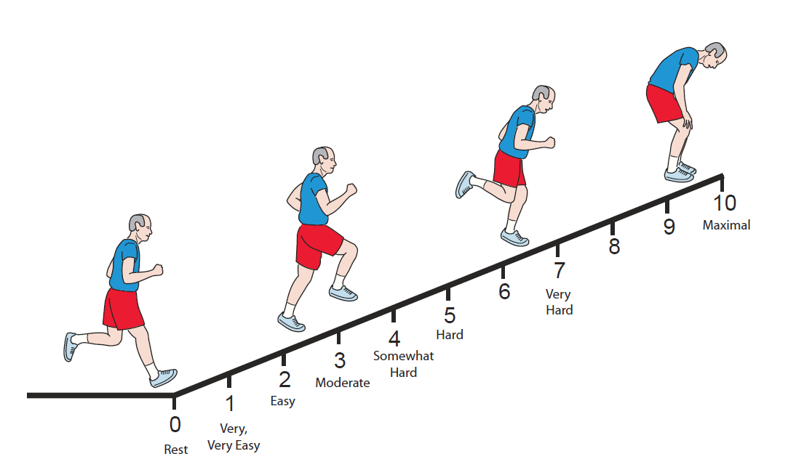

Appendix 2.

Table 1. Treadmill test increments

Increment | Time (m) | Speed (km/h) | Incline (%)
Start |  | 2.7 | 0.0
1 | 1:00 | 2.7 | 3.5
2 | 2:00 | 2.7 | 7.5
3 | 3:00 | 2.9 | 10.0
4 | 4:00 | 3.4 | 11.0
5 | 5:00 | 3.9 | 11.0
6 | 6:00 | 4.2 | 12.0
7 | 7:00 | 4.7 | 13.0
8 | 8:00 | 5.2 | 13.5
9 | 9:00 | 5.6 | 14.0
10 | 10:00 | 6.1 | 15.0
11 | 11:00 | 6.6 | 15.5
12 | 12:00 | 6.9 | 16.0
13 | 13:00 | 7.4 | 17.0
14 | 14:00 | 7.9 | 17.5
15 | 15:00 | 8.2 | 18.0
16 | 16:00 | 8.4 | 19.0
17 | 17:00 | 8.7 | 19.5
18 | 18:00 | 9.0 | 20.0
19 | 19:00 | 9.2 | 21.0
20 | 20:00 | 9.5 | 21.5

Table 2. Bike test increments

Increment | Time | Watts | RPM range
Start |  | 30 | 45-55
1 | 2:00 | 50 | 50-60
2 | 4:00 | 75 | 60-70
3 | 6:00 | 100 | 65-75
4 | 8:00 | 125 | 65-75
5 | 10:00 | 150 | 65-75
6 | 12:00 | 175 | 65-75
7 | 14:00 | 200 | 65-75
8 | 16:00 | 225 | 65-75
9 | 18:00 | 250 | 65-75
10 | 20:00 | End | End

Appendix 3.

Example SLI logbook – Submaximal exercise test
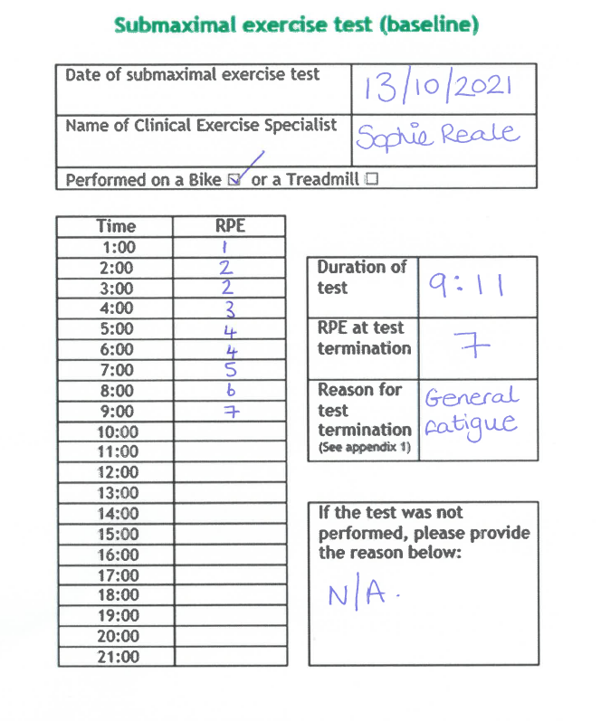

Appendix 4.

Example Run-in period

Target | Full STAMINA prescription | An example 'run-in' period*
Aerobic training  frequency | Twice per week | Once per week
Aerobic training  intensity | 60-85% HRmax or 40-60% HRR or 3-5 i.e. moderate to hard on the CR-10 RPE scale | 3 on the CR-10 scale i.e. moderate.
Aerobic training  duration | 30-45 minutes | 15-20 minutes
Resistance training  frequency | Twice per week | Once per week
Resistance training  intensity | Approx 60% of 1RM or 3-5 i.e. on the CR-10 RPE scale. | 3 on the CR-10 scale i.e. moderate.
Number of resistance exercises | Seven (Shoulders, glutes, upper legs, chest, upper arms, upper back, core) | Three (upper legs, shoulders, upper arms)
Number of resistance  sets | Up to 4 sets | Up to 2 sets
Number of resistance  reps | 8-12 | 8
* The specifics of what is required for each run-in period, and how long it lasts, will differ from patient to patient. Remember, the goal of the run-in period is to get the patient in to a position where they can undertake the full STAMINA exercise training prescription.

Appendix 5

Documenting the run-in period

