Name Unique ID

STAMINA Exercise CRF

Instructor name

Date from

Date until

STAMINA group sessions available

Monday | Tuesday | Wednesday | Thursday | Friday | Saturday | Sunday

If the patient did not attend an exercise session please record the details on page 13.
Max Hr (predicted):

55% HRmax (Inbar formula):

85% HRmax (Inbar formula):
Co-morbidities and functional limitations
Medications
Exercises to avoid
Details of run-in period (where applicable)
Frequency of sessions:

Duration of aerobic:

Reps/ sets of resistance:

Intensity:

Additional notes

Description of the aerobic exercise | Total duration (minutes) of each exercise
 | Session number
 | 1 | 2 | 3 | 4 | 5 | 6
Record the average RPE from the CR-10 scale
Record if the session was delivered (a) 1-2-1 or (b) to a group
Was HR recorded? Y/ N
Date of session
Session 1 - 6: Aerobic (target: 30- 45 minutes at 55-85% HR)

Session 1 - 6: Resistance (target: 4 sets & 8-12 reps per exercise)
Description of the resistance exercise | Total number of reps/ Weight (Kg or bodyweight)
 | Session number
 |  | 1 | 2 | 3 | 4 | 5 | 6
 | reps
 | weight
 | RPE
 | reps
 | weight
 | RPE
 | reps
 | weight
 | RPE
 | reps
 | weight
 | RPE
 | reps
 | weight
 | RPE
Session 7 - 12: Aerobic (target: 30- 45 minutes at 55-85% HR)
Description of the aerobic exercise | Total duration (minutes) of each exercise
 | Session number
 | 7 | 8 | 9 | 10 | 11 | 12
Record the average RPE from the CR-10 scale
Record if the session was delivered (a) 1-2-1 or (b) to a group
Was HR recorded? Y/ N
Date of session

Session 7 - 12: Resistance (target: 4 sets & 8-12 reps per exercise)
Description of the resistance exercise | Total number of reps/ Weight (Kg or bodyweight)
 | Session number
 |  | 7 | 8 | 9 | 10 | 11 | 12
 | reps
 | weight
 | RPE
 | reps
 | weight
 | RPE
 | reps
 | weight
 | RPE
 | reps
 | weight
 | RPE
 | reps
 | weight
 | RPE
Session 13 - 18: Aerobic (target: 30- 45 minutes at 55-85% HR)
Description of the aerobic exercise | Total duration (minutes) of each exercise
 | Session number
 | 13 | 14 | 15 | 16 | 17 | 18
Record the average RPE from the CR-10 scale
Record if the session was delivered (a) 1-2-1 or (b) to a group
Was HR recorded? Y/ N
Date of session

Session 13 - 18: Resistance (target: 4 sets & 8-12 reps per exercise)
Description of the resistance exercise | Total number of reps/ Weight (Kg or bodyweight)
 | Session number
 |  | 13 | 14 | 15 | 16 | 17 | 18
 | reps
 | weight
 | RPE
 | reps
 | weight
 | RPE
 | reps
 | weight
 | RPE
 | reps
 | weight
 | RPE
 | reps
 | weight
 | RPE
Session 19 - 24: Aerobic (target: 30- 45 minutes at 55-85% HR)
Description of the aerobic exercise | Total duration (minutes) of each exercise
 | Session number
 | 19 | 20 | 21 | 22 | 23 | 24
Record the average RPE from the CR-10 scale
Record if the session was delivered (a) 1-2-1 or (b) to a group
Was HR recorded? Y/ N
Date of session

Session 19 - 24: Resistance (target: 4 sets & 8-12 reps per exercise)
Description of the resistance exercise | Total number of reps/ Weight (Kg or bodyweight)
 | Session number
 |  | 19 | 20 | 21 | 22 | 23 | 24
 | reps
 | weight
 | RPE
 | reps
 | weight
 | RPE
 | reps
 | weight
 | RPE
 | reps
 | weight
 | RPE
 | reps
 | weight
 | RPE

Did not attend
Date of none attendance | Reason for non-attendance

Exercise prescription alterations

If the exercise prescription was not delivered in full for any reason other than an allocated ‘run-in’ period. Please document the details below:

Date of none attendance | Reason for non-attendance

How hard should men be working?

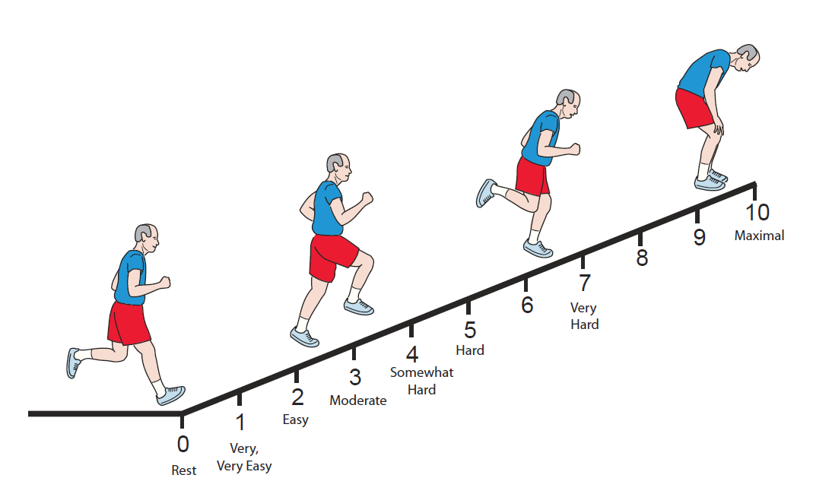
STAMINA participants will never be expected to work at their maximal level (10 on the ruler below). Instead you should encourage the men to work at a moderate intensity. This is between a 3 and a 5 on the scale below. Please ask the men how difficult the exercise feels and record the corresponding number. This scale works slightly different to your typical 1-10 scale, so please be cautious.

RPE - rate of perceived exertion

